Bad Column Name: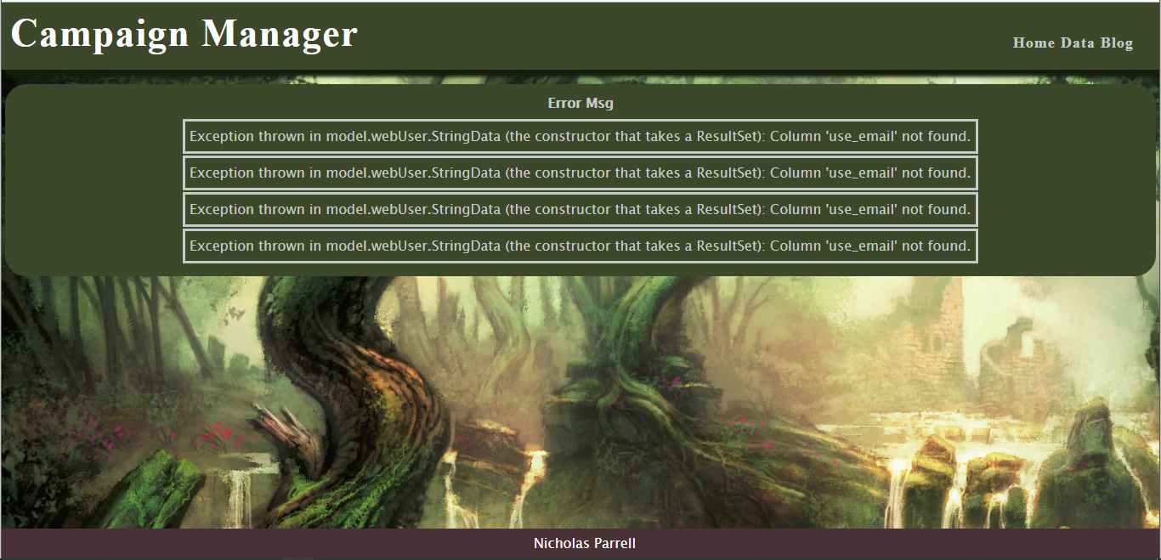

I changed the name of the column in the StringDataUser.java file so that they didn’t match up with the requested results list value. The fix is to find the table name that is wrong and change it to be the correct one.

Bad formatting type for parsing of results response: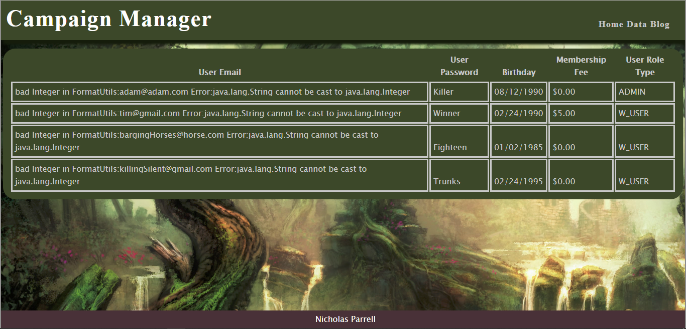

In the StringDataUser.java file you change the formatUtil to the wrong type. You fix this by changing it to the correct type.

Database SQL QUERY error: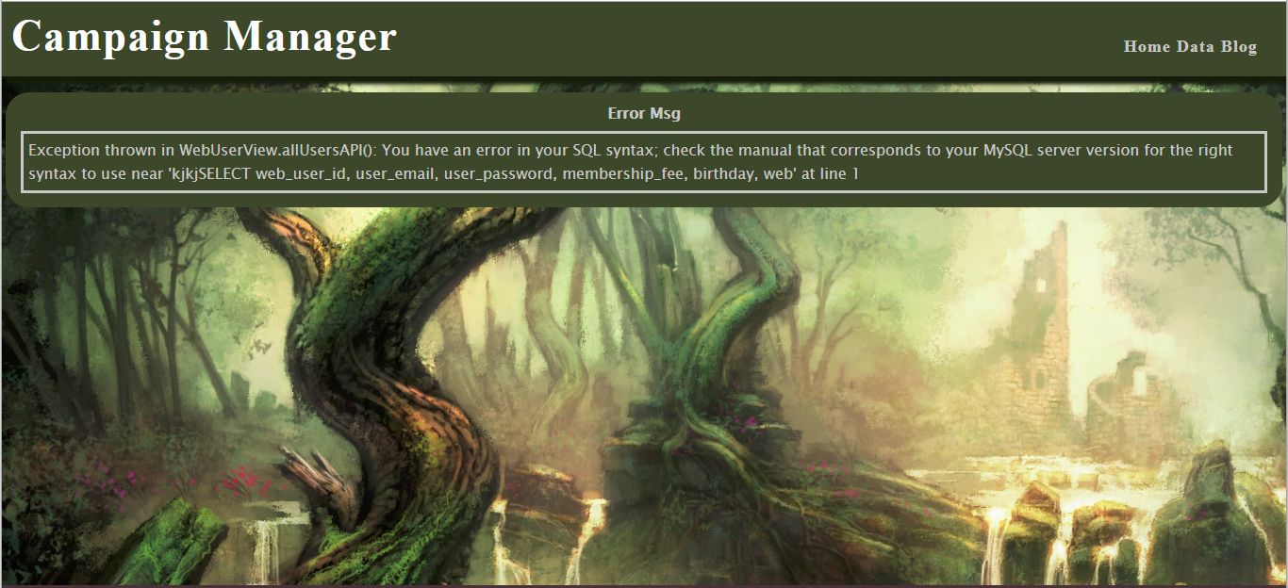

I entered the WebUserView.java and manipulated the SQL to start with jkjk. I fixed this error by navigating back to that section of code and removing it. If I didn’t know how this happened I would have copied the SQL querry and pasted it in the MYsql database tool. I would run the query and see what errors it pops up then correct them there until I get the desired results. I would then take the new SQL query and add it back to my WebUserView.java file.

Database Missing Driver: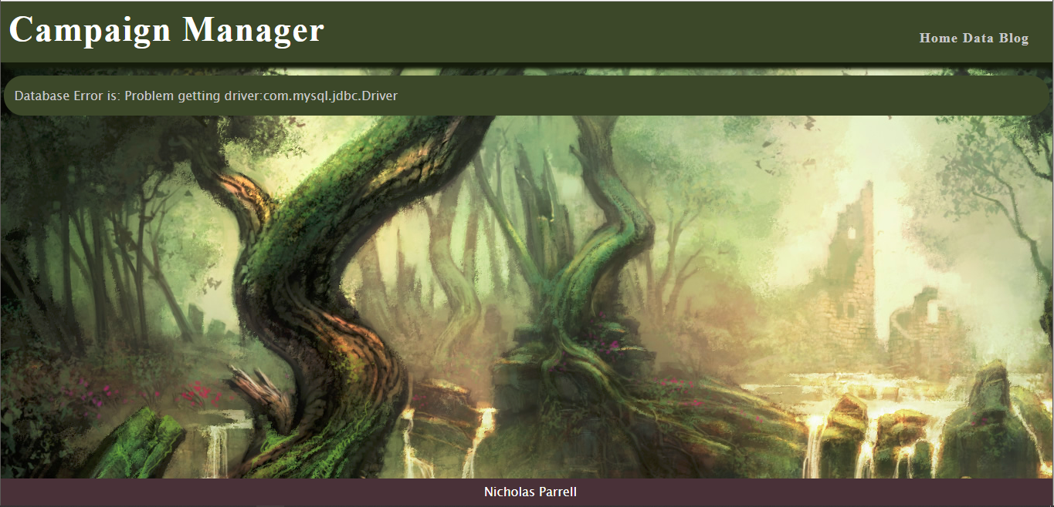

I removed the sql driver responsible for allowing the connection between my website and the mysql database. Fixed it by adding it back in.

Database Unaccessible: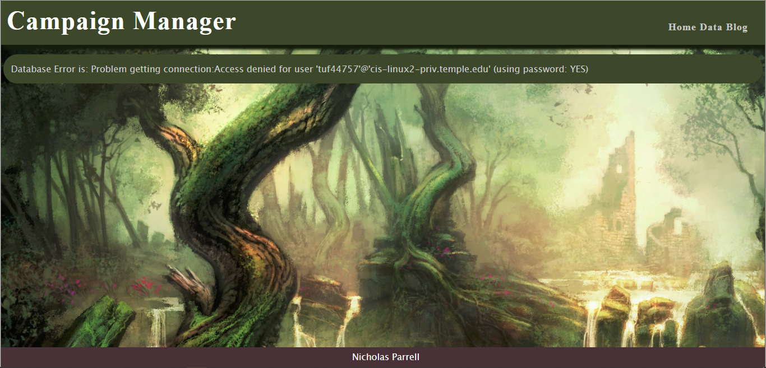

I put in the wrong password. I fixed it by putting in the right one.

Datebase Unavailable: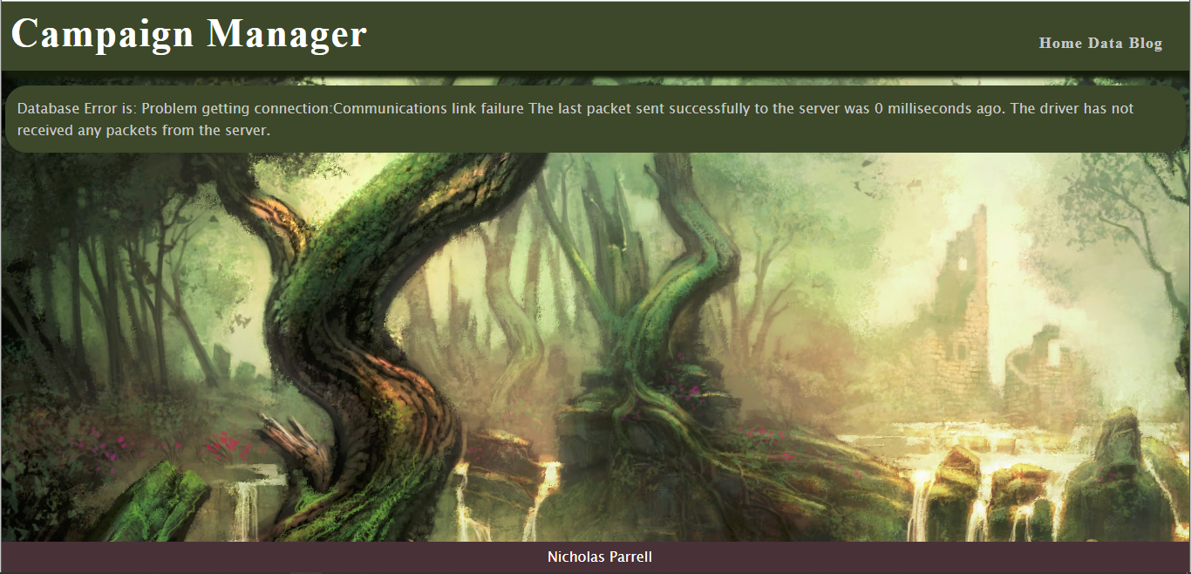

I didn’t tunnel into the cis-linux2.temple.edu server. I fixed it by tunneling into the cis-linux2.temple.edu server.